**Demo Project**

# High architecture of demo project

# Overall description

The demo has the following main projects:

* API Gateway: Ocelot Gateway
* Identity Provider: IdentityProvider
* Consumer: ConsumerApplication1
* API: WebApi1, WebApi2
* Requests:
  + GetExternalCall: Consumer1 -> IdP -> Ocelot -> WebApi1 -> WebApi2
  + Get1: Consumer1 -> IdP -> Ocelot -> WebApi1
  + Get2: Consumer1 -> Ocelot -> WebApi2

# How to run solution

* Run infrastructure: Open the solution’s folder and run docker-compose up -d  
  Infrastructure includes:
  + Seq
  + Consul
  + Jaeger
  + Mssql
  + Prometheus
  + Grafana
* F5 to run main projects
* Call API to ConsumerApplication1 to test the result
* Run localhost:16686 to view traces of request
* Runt localhost:5342 to view the log of request

# Detail description

## ConsumerApplication1

### Connect to IdentityProvider to get access token

### Export open telemetry to Jaeger for tracing

### Configure HttpClient

## IdentityProvider

### Add IdentityServer4



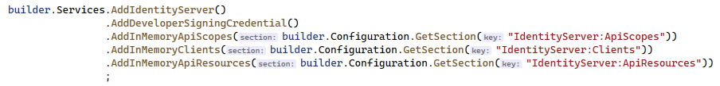

### Configure ApiScopes

### Configure Clients

### Configure ApiResources

## Ocelot Gateway

### Add Ocelot

### Verify with IdentityProvider

### Configure Serilog into Seq

### Export open telemetry to Jaeger for tracing

### Add Consul

### Configure Routing

## WebApi1

### Configure Serilog into Seq

### Verify with IdentityProvider

### Configure HttpClient

* Add Entity Framework



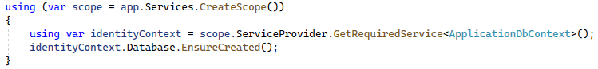

### Configure Consul

### Export open telemetry to Jaeger for tracing

### Create metrics endpoint for prometheus

# Install software in Windows Server

## Install Seq

Download and install following GUI

## Install Consul

## Install Jaeger

#### Install ElasticSearch

#### Install Jaeger

## Install Prometheus

## Install Grafana

## Install Ocelot

Like all Asp.Net Core applications

## Install IdentityProvider

#### Create Certificate and Install

docker run --rm -it -v /D/Work/GeneratedCertificates:/work nginx bin/bash

openssl req -x509 -sha512 -newkey rsa:4096 -days 3650 -keyout /work/crawler.key -out /work/crawler.crt

openssl pkcs12 -inkey /work/crawler.key -in /work/crawler.crt -export -out /work/crawler.pfx

In windows server, type mmc command

Choose pfx and import

Add certification’s permission for IIS_IUSRS and NETWORK_SERVICE

Copy certificate into folder Trusted Root Certification Authorities

#### Install IdentityProvider and configure certificate

IdentityProvider can use certificate of host through thumbprint of certificate which installed into server

